**GREEDY METHOD**

**JOB SEQUENCING WITH DEADLINES-**

**Problem-**

 Given the jobs, their deadlines and associated profits as shown-

|  |  |  |  |  |  |  |
| --- | --- | --- | --- | --- | --- | --- |
| **Jobs** | **J1** | **J2** | **J3** | **J4** | **J5** | **J6** |
| **Deadlines** | 5 | 3 | 3 | 2 | 4 | 2 |
| **Profits** | 200 | 180 | 190 | 300 | 120 | 100 |

 Answer the following questions-

1. Write the optimal schedule that gives maximum profit.
2. Are all the jobs completed in the optimal schedule?
3. What is the maximum earned profit?

**Solution-**

**Step-01:**

 Sort all the given jobs in decreasing order of their profit-

|  |  |  |  |  |  |  |
| --- | --- | --- | --- | --- | --- | --- |
| **Jobs** | **J4** | **J1** | **J3** | **J2** | **J5** | **J6** |
| **Deadlines** | 2 | 5 | 3 | 3 | 4 | 2 |
| **Profits** | 300 | 200 | 190 | 180 | 120 | 100 |

**Step-02:**

Value of maximum deadline = 5.

So, draw a Gantt chart with maximum time on Gantt chart = 5 units as shown-

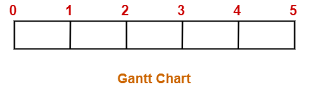

Now,

* We take each job one by one in the order they appear in Step-01.
* We place the job on Gantt chart as far as possible from 0.

**Step-03:**

* We take job J4.
* Since its deadline is 2, so we place it in the first empty cell before deadline 2 as-

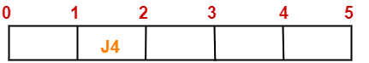

**Step-04:**

* We take job J1.
* Since its deadline is 5, so we place it in the first empty cell before deadline 5 as-

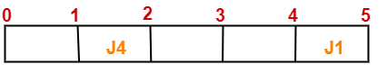

**Step-05:**

* We take job J3.
* Since its deadline is 3, so we place it in the first empty cell before deadline 3 as-

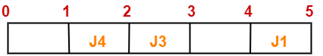

**Step-06:**

* We take job J2.
* Since its deadline is 3, so we place it in the first empty cell before deadline 3.
* Since the second and third cells are already filled, so we place job J2 in the first cell as-

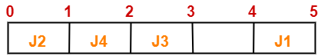

**Step-07:**

* Now, we take job J5.
* Since its deadline is 4, so we place it in the first empty cell before deadline 4 as-

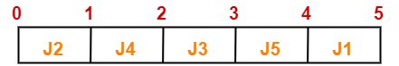

Now,

* The only job left is job J6 whose deadline is 2.
* All the slots before deadline 2 are already occupied.
* Thus, job J6 can not be completed.

Now, the given questions may be answered as-

**Part-01:**

The optimal schedule is-

**J2  , J4 , J3 , J5 , J1**

This is the required order in which the jobs must be completed in order to obtain the maximum profit.

**Part-02:**

* All the jobs are not completed in optimal schedule.
* This is because job J6 could not be completed within its deadline.

**Part-03:**

Maximum earned profit

= Sum of profit of all the jobs in optimal schedule

= Profit of job J2 + Profit of job J4 + Profit of job J3 + Profit of job J5 + Profit of job J1

= 180 + 300 + 190 + 120 + 200

= 990 units